Task 1: To Change Directories, Validate Paths, Update Working Directory, Handle Errors, Maintain Previous Directory, Test Navigation.
Code:
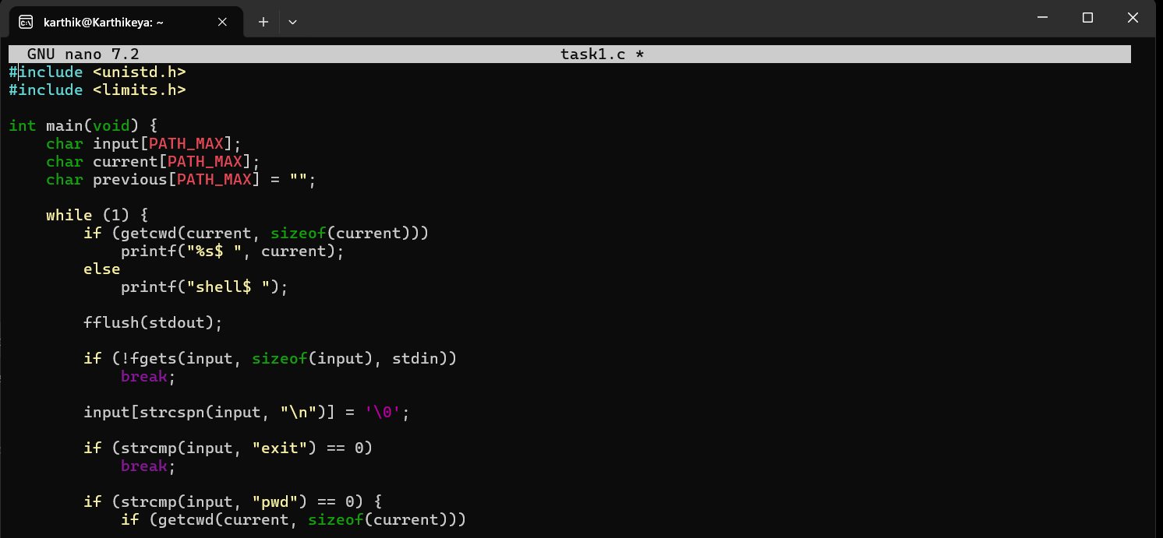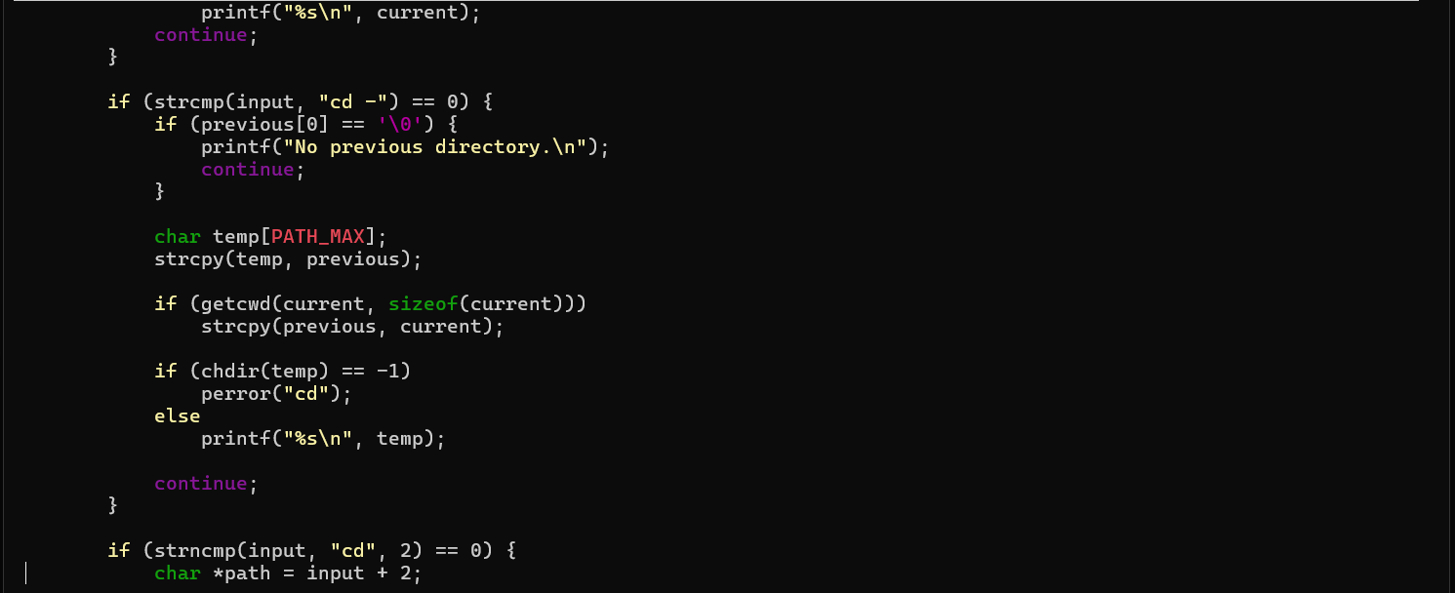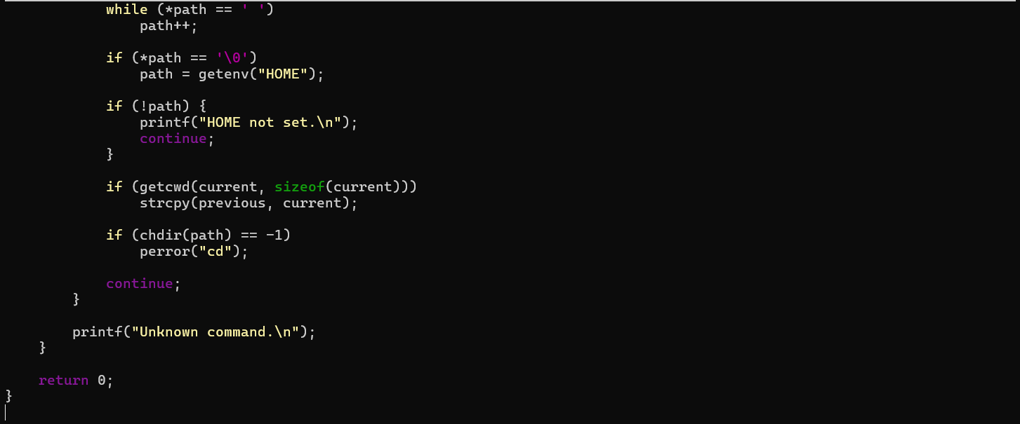

Output :
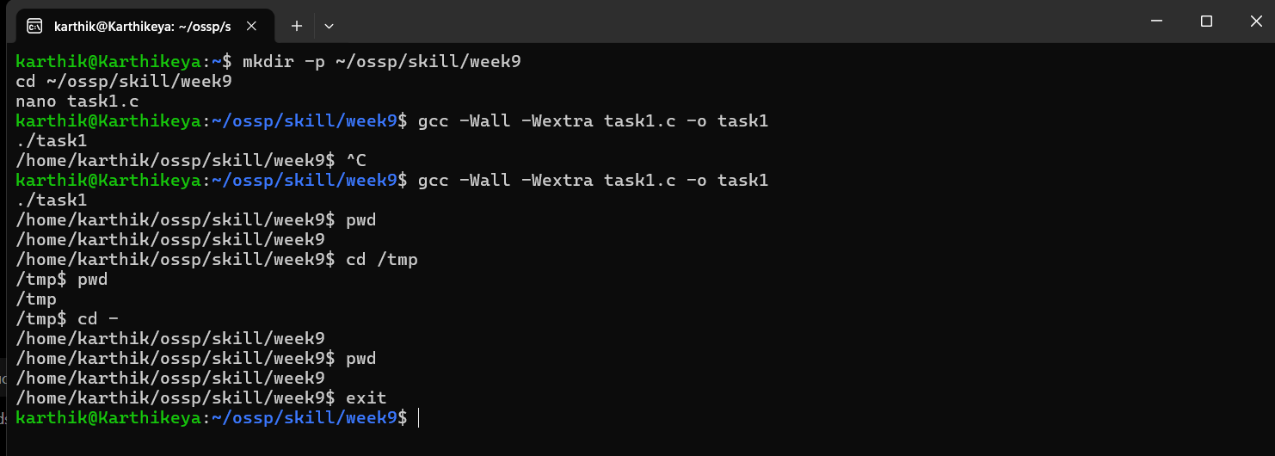

Task 2: To Identify Built-ins, Create Dispatch Table, Execute In-Process Commands, Handle Invalid Commands, Maintain State, Test Dispatch Logic.
Code:
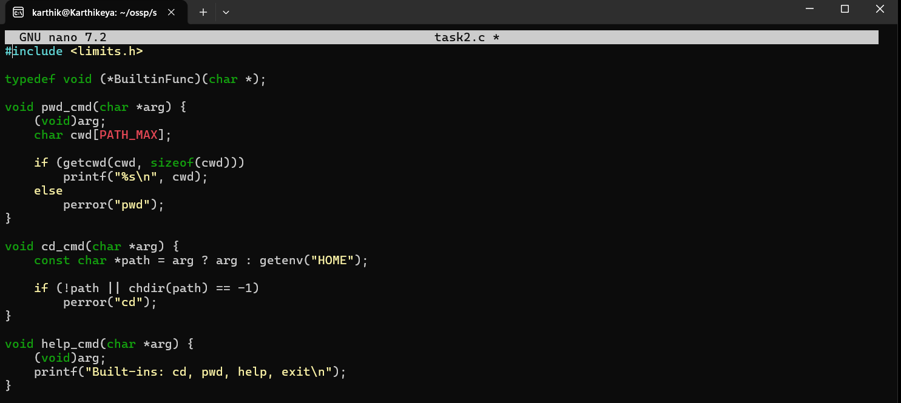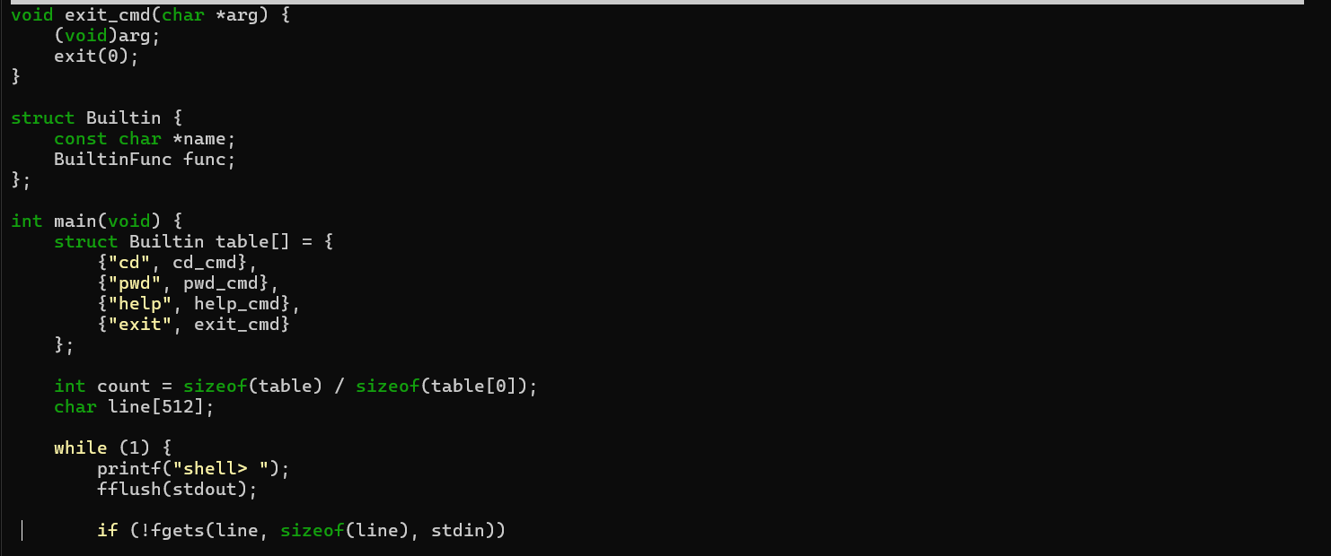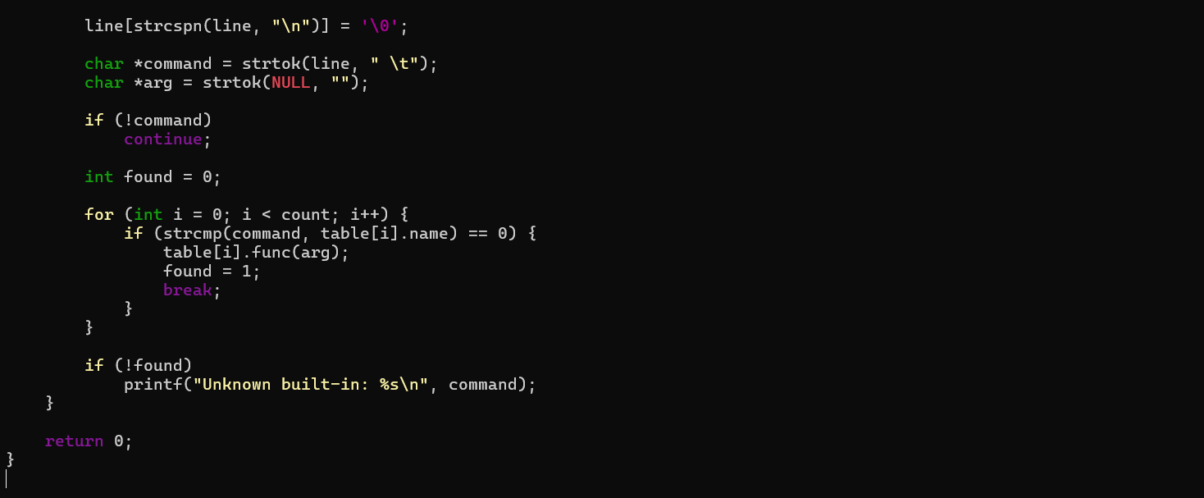

Output:
